

**PROJECT TITLE: VEHICLE RESALE PREDICTION**

**Submitted By:**

S SAI CHAITANYA

MD KHAJA MOHIDDIN

MIR NASAR ALI

K SANDEEP

G RAVITEJA

***CERTIFICATE***

This is to certify that this project based Class report entitled **“VEHICLE RESALE PREDICTION ”** is a bonafide work done by S SAI CHAITANYA, MD.KHAJA MOHIDDIN,MIR NASAR ALI, K.SANDEEP, G.RAVITEJA in partial fulfillment of the requirement for the award of **internship conducted by smart bridge** during the summer 2019.

***DECLARATION***

We hereby declare that this project based lab report entitled“**VEHICLE RESALE PREDICTION”** has been prepared by us in partial fulfillment of the requirement for the award of**internship conducted by smart bridge** during the summer 2019.

We also declare that this project based class report is of our own effort and it has not been submitted to any other university for the award of any degree.

**Date: 22-06-2019**

**Place: Hyderabad**

**Submitted By:**

S SAI CHAITANYA

MD KHAJA MOHIDDIN

MIR NASAR ALI

K SANDEEP

G RAVITEJA

**TABLE OF CONTENTS**

1.Abstract…………………………………..

2.Introduction………………………………

3.Importing Packages………………………

4.Exploratory Data Analysis……………….

5.Plots and Models………………………….

6.Algorithms………………………………..

7.Result…………………………………….

8.Conclusion……………………………….

**INTRODUCTION**

* Regression analysis consists of a set of machine learning methods that allow us to predict a continuous outcome variable (y) based on the value of one or multiple predictor variables (x).
* Briefly, the goal of regression model is to build a mathematical equation that defines y as a function of the x variables. Next, this equation can be used to predict the outcome (y) on the basis of new values of the predictor variables (x).
* Linear regression is the most simple and popular technique for predicting a continuous variable. It assumes a linear relationship between the outcome and the predictor variables.

**PROBLEM STATEMENT**

Several were taken and we should predicts the cost ot the products in the future.By taking all the inputs we were predicting the cost,so by using regression concept we can predict the cost in future,by using multiple regression the concept made so easy,we can easily predict the future values of any product like from stock market we need predict the future market price of the products from the present price.In this project we need predict the price of the car (Independent variable) from the length, height, width, wheel base, horsepower of the car(dependent variables).

**3.Importing packages**

* Numpy
* Pandas
* Imputer
* Seaborn
* Matplotlib
* Sklearn(Logistic Regression, SVC, Decision Tree Classifier,

Random Forest Classifier)

Node-RED flow:

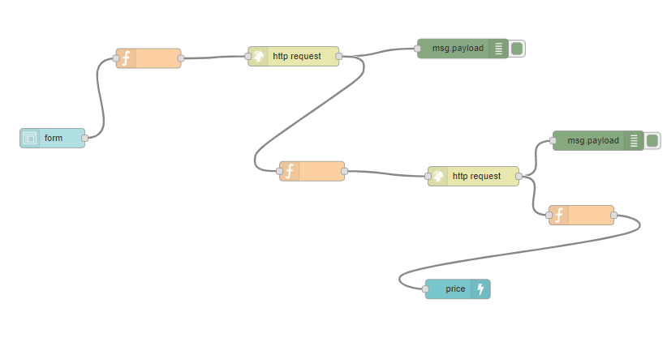

Reading the csv file

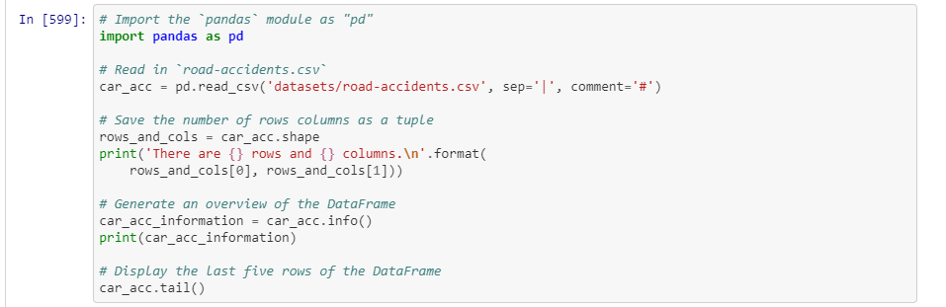

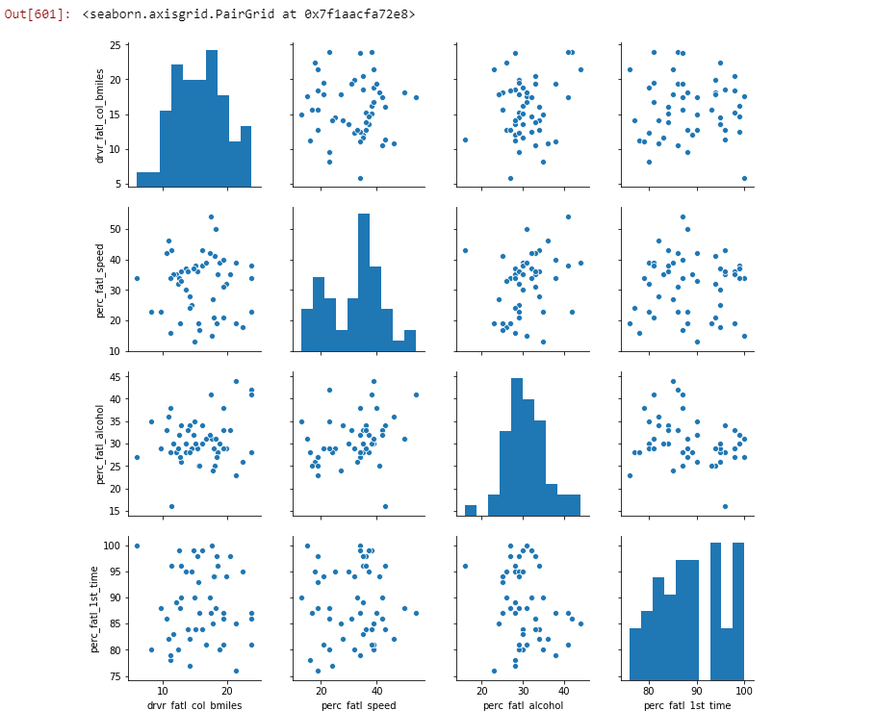

Multivariate linear regression

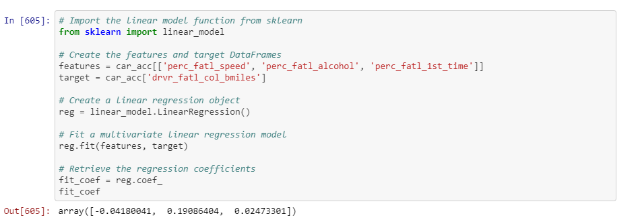

Find clusters of similar states in the data

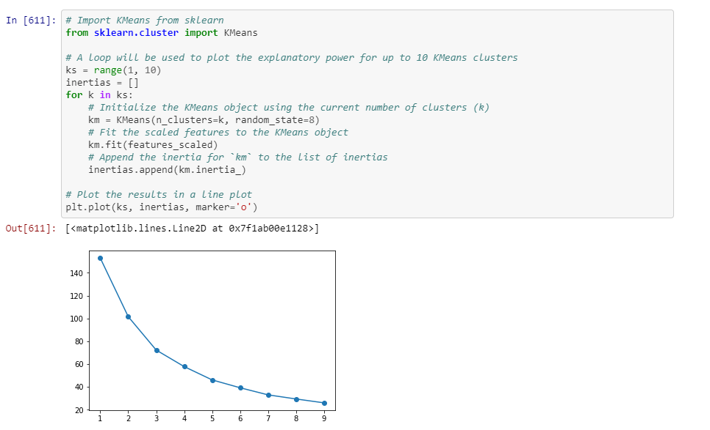

Visualize the feature differences 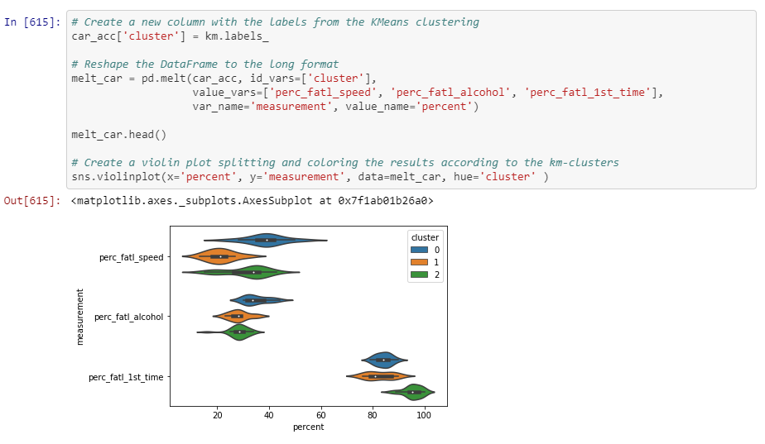

In put and Out put of Node-RED flow:

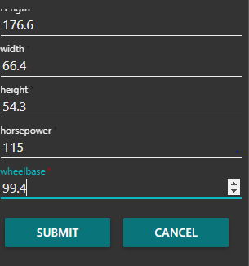

**RESULT**

These are the following observations from the above models:

* The accuracy of Logistic regression on test set is:0.8

**CONCLUSION**

By using the regression we can easily predict the future values of any product like from stock market we need predict the future market price of the products from the present price.In this project we need predict the price of the car (Independent variable) from the length, height, width, wheel base, horsepower of the car(dependent variables).